Acceptance Test Data Sheets

For

Skyryse Flight OS LEMA TPX 325

|  |  |
| --- | --- |
| LEMA Assembly Part Number | Serial Number |
|  | 1234 |

**Full test results: Fail**

|  |  |
| --- | --- |
| **Group** | **Pass/Fail** |
| **6.1. Visual Examination of the Product** | Pass |
| **6.2 Weight** | Pass |
| 6.3 Bonding | Pass |
| **6.4 Resistance** | Fail |
| **6.5 Inductance** | Fail |
| **6.5 Power ON UUT Checks** | Pass |
| **6.7.2 N1 and N2 Extend Mechanical Stops and MCE Rigging** | Fail |
| **6.7.3 N1 and N2 Stroke Check** | Fail |
| **6.7.4 Brake Release Test** | Pass |
| **6.7.5 Performance Test – Unloaded Operation** | Fail |
| **6.7.6 Performance Test – Loaded Operation** | Fail |
| **6.7.7 Holding Load Test** | Fail Fail |
| **6.7.8 Backlash** | Fail |

6.1. Visual Examination of the Product

|  |  |
| --- | --- |
| UUT conforms to the requirements of paragraph 6.1 | True |

6.2 Weight

|  |  |
| --- | --- |
| UUT weight should not exceed 10 lbs | actual weight 12 lbs |

6.3 Bonding

Bonding resistance

|  |  |  |  |  |
| --- | --- | --- | --- | --- |
|  | **Expected** | **Tolerance** | **Simplex** | **Duplex** |
|  | (mOhms) | (mOhms) | (mOhms) | (mOhms) |
| Motor End Cap | 2.5 | 0.5 | 2 | 2.1 |
| Solenoid housing | 2.5 | 0.5 | 2 | 2.2 |
| Encoder cover | 2.5 | 0.5 | 2 | 2.3 |

6.4 Resistance and Inductance Test (motor and solenoid)

**Resistances:**

|  |  |  |  |  |  |
| --- | --- | --- | --- | --- | --- |
|  | **Expected** | **Tolerance** | **Connector J1** | **Connector J2** | **Connector J3** |
| Pins | Resistance (Ohms) | Resistance (Ohms) | Resistance (Ohms) | Resistance (Ohms) | Resistance (Ohms) |
| E to F | 0.212 mOhms | 0.0212 Ohms | 0.2 Ohms | 0 Ohms | 0 Ohms |
| F to G | 0.212 mOhms | 0.0212 Ohms | 0.21 Ohms | 0 Ohms | 0 Ohms |
| G to E | 0.212 mOhms | 0.0212 Ohms | 0.22 Ohms | 0 Ohms | 0 Ohms |
| A to L | 6.55 mOhms | 0.44 Ohms | 45 Ohms | 55 Ohms | 56 Ohms |
| G,F,E,A,L tied together to chassis grounds. Apply 500VDC | 5000000 mOhms | 0 Ohms | 1E+7 Ohms | 1E+9 Ohms | 1E+8 Ohms |

**Inductances:**

|  |  |  |  |  |  |  |
| --- | --- | --- | --- | --- | --- | --- |
|  | | **Expected** | **Tolerance** | **Connector J1** | **Connector J2** | **Connector J3** |
|  | | Inductance  (mH) | Inductance  (mH) | Inductance  (mH) | Inductance  (mH) | Inductance  (mH) |
| E to F | 0.155 | | 0.02325 | 0 | 0 | 0 |
| F to G | 0.155 | | 0.02325 | 0 | 0 | 0 |
| G to E | 0.155 | | 0.02325 | 0 | 0 | 0 |
| A to L | 22 | | 3.3 | 0 | 1 | 0 |

6.5 Power ON UUT Checks

Confirm all sensors are reporting nominal values and no faults reported

|  |  |  |
| --- | --- | --- |
| Sensor | Value | Pass/Fail |
| Motor 1 | 0 | Pass |
| Motor 2 | 0 | Pass |
| Motor 3 | -0.0032 | Pass |
| M1 | 0 | Pass |
| M2 | 0 | Pass |
| M3 | 0 | Pass |
| Faults 1 | 0 | Pass |
| Faults 2 | 0 | Pass |
| Faults 3 | 0 | Pass |

6.6 Functional Check Out

6.6.1 **MCE1, MCE 2, MCE3 Power Up**

|  |  |  |  |
| --- | --- | --- | --- |
| Description | Ballnut position | Pass/Fail | |
| MCE 1 reports values for Ballnut position and motor current | 0 | Ballnut Position | Current |
| Pass | Pass |
| (Simulated) FCC/reports values for M1(QPS) | -0 | Pass |  |
| MCE 2 reports values for Ballnut position and motor current | 0 | Pass | Pass |
| (Simulated) FCC/reports values for M2(QPS) | -0 | Pass |  |
| MCE 3 reports values for Ballnut position and motor current | -0.0092 | Pass | Pass |
| (Simulated) FCC/reports values for M3(QPS) | -0 | Pass |  |

6.7.2 N1 and N2 Extend Mechanical Stops and MCE Rigging

**CALIBRATION ADDITON TO MCE (NEW)**

**Step 6.7.2.1** **Extend using M1/N1**

|  |  |  |
| --- | --- | --- |
| Description | Value | Pass/Fail |
| N1 extend stop engaged (M1 current saturated) | 1024 | Pass |
| MCE 1 Motor Current 4.5 +/- 0.15 Amps | 6.011 Amps | Failed |
| Linear Encoder Value | 0.0582 | Pass |
| N1 is Rigged | 0 | Pass |

**Step 6.7.2.2** **Extend using M2/N2**

|  |  |  |
| --- | --- | --- |
| Description | Value | Pass/Fail |
| N2 extend stop engaged (M2 current saturated) | 1024 | Pass |
| MCE2 Motor Current 4.5 +/- 0.15 Amps | 6.0069 Amps | Failed |
| Linear Encoder Value | 0.0331 | Pass |
| N2 (Motor 2) is Rigged | 0 | Pass |
| N2 (Motor 3) is Rigged | 0 | Pass |

6.7.3 N1 and N2 Stroke Check

|  |  |  |
| --- | --- | --- |
| Pin to pin Length is 16.732 +/- TBD (ins) | Pin to Pin Length | Pass/Fail |
|  |  |
| Description | Actual Position N1/N2 | Pass/Fail |
| N2 at -0.575 ins from Null using M2 | -0.575 | Pass |
| N1 at +1.725 ins from Null using M1 | 1.725 | Pass |
| N1 at -0.575 ins from Null using M1 | -0.5753 | Pass |
| N2 at +1.725 ins from NULL using M2 | 1.7257 | Pass |
| N1 at -0.575 ins from Null using M1 | -0.5747 | Pass |
| N2 at +1.725 ins from Null using M3 | 1.725 | Pass |
| N2 at -0.575 ins from Null using M3 | -0.5734 | Pass |

MOTOR 1

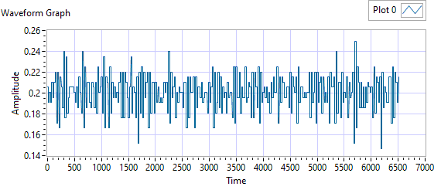

Figure - Ballnut Velocity for Motor One

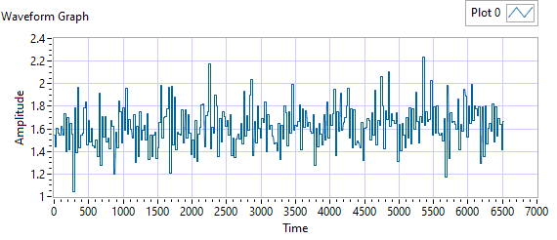

Figure -Current for Motor One

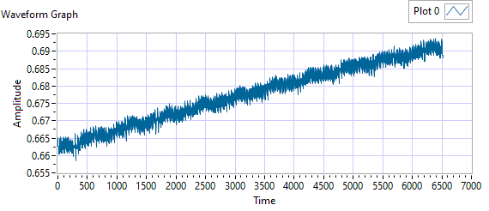

Figure - M1 Delta for Motor One

|  |  |  |  |  |  |
| --- | --- | --- | --- | --- | --- |
| **Description** | **Expected** | **Tolerance** | **Actual Average** | **Peak Velocity** | **Pass/Fail** |
| Constant Velocity | 0.2 | 0.02 | 0.2003 | 0.2496 | Failed |
| **Description** | **Expected** | **Tolerance** | **Actual** | **Standard Deviation** | **Pass/Fail** |
| Delta between Motor 1 Position and M1 position | 0.1 | 0.2 | 1.5994 | 0.0086 | Failed |
| Delta between Motor 1 Position and Linear Encoder position | 0.1 | 0.2 | 0.6937 | 0.3762 | Failed |
| Motor Current |  |  | 1.6213 | 0.1813 |  |

|  |  |  |  |  |
| --- | --- | --- | --- | --- |
| Description | Expected Difference from Test rig encoder | Tolerance | Difference from Test rig encoder | Pass/Fail |
| Motor 1 position + Motor 2 position = test rig encoder | 0 | 0.1 | 0.1025 | Failed |
| Motor1 position + Motor 3 position = test rig encoder | 0 | 0.1 | 0.1025 | Failed |
| M1 position + M2 position = test rig encoder | 0.1 | 0.1 | -0.2725 | Failed |
| M1 position + M3 position = test rig encoder | 0 | 0.1 | -0.2725 | Failed |
| Difference between Motor 2 position and Motor 3 position is < TBD ins | 0 | 0.1 | 0 | Pass |
| Difference between M2 position and M3 position is < TBD ins | 0 | 0 | 0 | Pass |
| Difference between Motor 1 position and M1 position is < TBD ins | 0 | 0.1 | 0.95 | Failed |
| Difference between Motor 2 position and M2 position is < TBD ins | 0 | 0.1 | 0.575 | Failed |
| Difference between Motor 3 position and M3 position is < TBD ins | 0 | 0.1 | 0.575 | Failed |

MOTOR 2

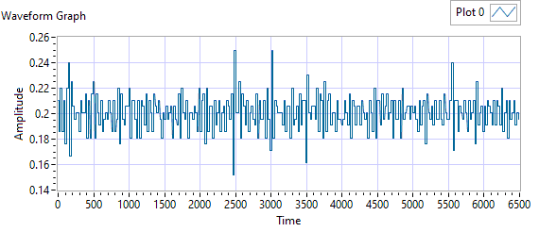

Figure - Ballnut Velocity for Motor Two

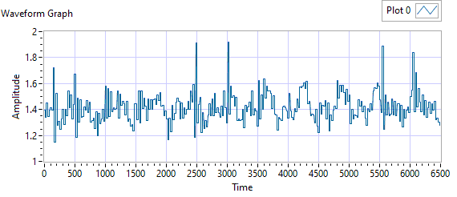

Figure -Current for Motor Two

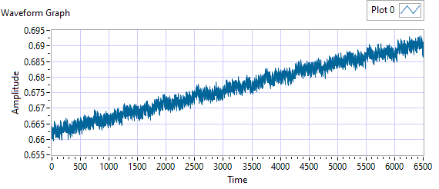

Figure - M1 Delta for Motor Two

|  |  |  |  |  |  |
| --- | --- | --- | --- | --- | --- |
| **Description** | **Expected** | **Tolerance** | **Actual Average** | **Peak Velocity** | **Pass/Fail** |
| Constant Velocity | 0.2 | 0.02 | 0.2007 | 0.2496 | Failed |
| **Description** | **Expected** | **Tolerance** | **Actual** | **Standard Deviation** | **Pass/Fail** |
| Delta between Motor 2 Position and M2 position | 0.1 | 0.2 | 1.5968 | 0.0082 | Failed |
| Delta between Motor 2 Position and Linear Encoder position | 0.1 | 0.2 | 0.6932 | 0.3749 | Failed |
| Motor Current |  |  | 1.4169 | 0.1123 |  |

|  |  |  |  |  |
| --- | --- | --- | --- | --- |
| Description | Expected Difference from Test rig encoder | Tolerance | Difference from Test rig encoder | Pass/Fail |
| Motor 1 position + Motor 2 position = test rig encoder | 0 | 0.1 | 0.1017 | Failed |
| Motor1 position + Motor 3 position = test rig encoder | 0 | 0.1 | 0.1017 | Failed |
| M1 position + M2 position = test rig encoder | 0.1 | 0.1 | -0.2579 | Failed |
| M1 position + M3 position = test rig encoder | 0 | 0.1 | -0.2579 | Failed |
| Difference between Motor 2 position and Motor 3 position is < TBD ins | 0 | 0.1 | 0.0015 | Pass |
| Difference between M2 position and M3 position is < TBD ins | 0 | 0 | 0 | Pass |
| Difference between Motor 1 position and M1 position is < TBD ins | 0 | 0.1 | 0.575 | Failed |
| Difference between Motor 2 position and M2 position is < TBD ins | 0 | 0.1 | 0.9346 | Failed |
| Difference between Motor 3 position and M3 position is < TBD ins | 0 | 0.1 | 0.9346 | Failed |

MOTOR 3

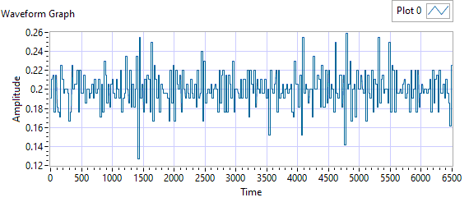

Figure - Ballnut Velocity for Motor Three

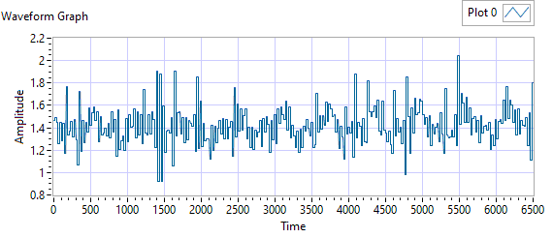

Figure -Current for Motor Three



Figure - M3 Delta for Motor Three

|  |  |  |  |  |  |
| --- | --- | --- | --- | --- | --- |
| **Description** | **Expected** | **Tolerance** | **Actual Average** | **Peak Velocity** | **Pass/Fail** |
| Constant Velocity | 0.2 | 0.02 | 0.2002 | 0.2594 | Failed |
| **Description** | **Expected** | **Tolerance** | **Actual** | **Standard Deviation** | **Pass/Fail** |
| Delta between Motor 3 Position and M3 position | 0.1 | 0.2 | 1.5863 | 0.0084 | Failed |
| Delta between Motor 3 Position and Linear Encoder position | 0.1 | 0.2 | 0.6933 | 0.3753 | Failed |
| Motor Current |  |  | 1.4201 | 0.1659 |  |

|  |  |  |  |  |
| --- | --- | --- | --- | --- |
| Description | Expected Difference from Test rig encoder | Tolerance | Difference from Test rig encoder | Pass/Fail |
| Motor 1 position + Motor 2 position = test rig encoder | 0 | 0.1 | 0.1019 | Failed |
| Motor1 position + Motor 3 position = test rig encoder | 0 | 0.1 | 0.1019 | Failed |
| M1 position + M2 position = test rig encoder | 0.1 | 0.1 | -0.2728 | Failed |
| M1 position + M3 position = test rig encoder | 0 | 0.1 | -0.2729 | Failed |
| Difference between Motor 2 position and Motor 3 position is < TBD ins | 0 | 0.1 | 0.0014 | Pass |
| Difference between M2 position and M3 position is < TBD ins | 0 | 0 | 0 | Pass |
| Difference between Motor 1 position and M1 position is < TBD ins | 0 | 0.1 | 0.575 | Failed |
| Difference between Motor 2 position and M2 position is < TBD ins | 0 | 0.1 | 0.9497 | Failed |
| Difference between Motor 3 position and M3 position is < TBD ins | 0 | 0.1 | 0.9498 | Failed |

6.7.4 Brake Release Test

**Step d –** LEMA reaches commanded position

|  |  |  |  |  |
| --- | --- | --- | --- | --- |
| Description | Expected | Tolerance | Position | Pass/Fail |
| MCE1 /Motor 1 | 0.2 |  | 0.187 | Pass |
| MCE2 /Motor 2 | 0.2 |  | 0.1876 | Pass |
| MCE3 /Motor 3 | 0.2 |  | 0.1817 | Pass |

6.7.5 Performance Test – unloaded operation **(one channel operation)**

**6.7.5.1.1 MCE 1 - Step Response Test**

**The result for motor one is shown below:**

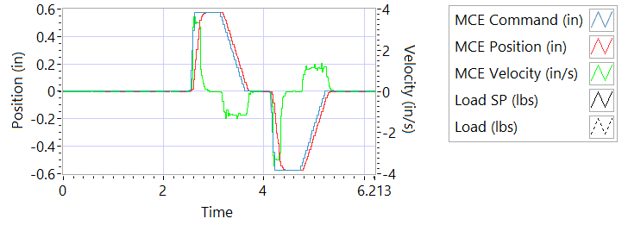

Figure - Results for Motor One

**Step d Extension**

|  |  |  |
| --- | --- | --- |
| Description | Actual Speed / Time | Pass/Fail |
| No Load speed is 2.7 to 3.3 in/sec | 2.9811 | True |
| Time to achieve 80% of the specified stroke (+ 0.575 ins) is 170+9/-9 ms seconds | 209 | Failed |

**Step e Retraction**

|  |  |  |
| --- | --- | --- |
| Description | Actual Speed / Time | Pass/Fail |
| No Load speed is 2.7 to 3.3 in/sec | -3.0614 | Failed |
| Time to achieve 80% of the specified stroke (- 0.575 ins) is 170+9/-9 ms seconds | 204 | Failed |

**6.7.5.1.2 MCE 1 - Frequency Response**

**Step d**

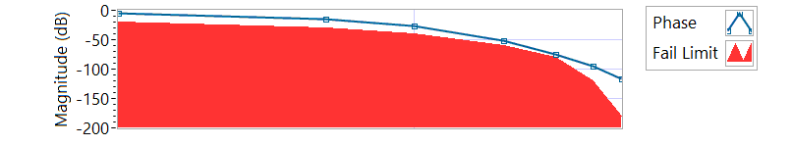

Figure - Phase for Motor One

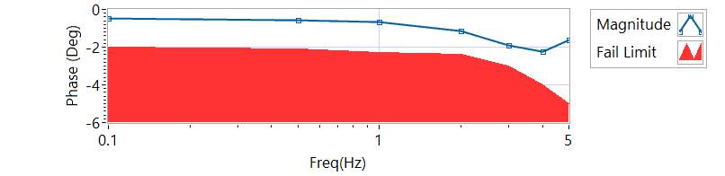

Figure - Magnitude for Motor One

**Frequency Response**

|  |  |  |  |  |
| --- | --- | --- | --- | --- |
| **Frequency** | **Magnitude**  **(dB)** | **Phase**  **(deg)** | **Min phase** | **Pass/Fail** |
| 0.1 Hz | -0.496881 | -5.5332 | -20 | Pass |
| 0.5 Hz | -0.554981 | -15.318 | -30 | Pass |
| 1 Hz | -0.6576 | -27.18 | -40 | Pass |
| 2 Hz | -1.1428 | -51.336 | -60 | Pass |
| 3 Hz | -1.92545 | -74.52 | -80 | Pass |
| 4 Hz | -2.22221 | -95.328 | -120 | Pass |
| 5 Hz | -1.63907 | -116.82 | -180 | Pass |

6.7.5.2.1 **MCE 2 - Step Response Test**

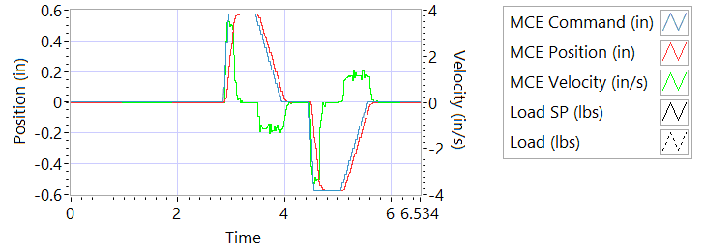

Figure - Results for Motor Two

**Step d Extension**

|  |  |  |
| --- | --- | --- |
| Description | Actual Speed / Time | Pass/Fail |
| No Load speed is 2.7 to 3.3 in/sec | 3.2749 | True |
| Time to achieve 80% of the specified stroke (+ 0.575 ins) is 170+9/-9 ms seconds | 188 | Failed |

**Step e Retraction**

|  |  |  |
| --- | --- | --- |
| Description | Actual Speed / Time | Pass/Fail |
| No Load speed is 2.7 to 3.3 in/sec | -3.3232 | Failed |
| Time to achieve 80% of the specified stroke (- 0.575 ins) is 170+9/-9 ms seconds | 184 | Failed |

6.7.5.2.2 **MCE 2 - Frequency Response Test**

**Step d**

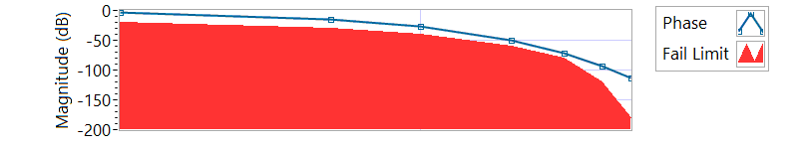

Figure - Phase for Motor Two

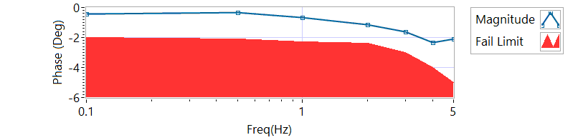

Figure - Magnitude for Motor Two

**Frequency Response**

|  |  |  |  |  |
| --- | --- | --- | --- | --- |
| **Frequency** | **Magnitude**  **(db)** | **Phase**  **(Deg)** | **Min phase**  **(Deg)** | **Pass/Fail** |
| 0.1 Hz | -0.410454 | -3.9996 | -20 | Pass |
| 0.5 Hz | -0.353309 | -14.994 | -30 | Pass |
| 1 Hz | -0.642865 | -25.956 | -40 | Pass |
| 2 Hz | -1.12722 | -50.112 | -60 | Pass |
| 3 Hz | -1.64009 | -72.252 | -80 | Pass |
| 4 Hz | -2.32044 | -94.032 | -120 | Pass |
| 5 Hz | -2.0958 | -112.86 | -180 | Pass |

6.7.5.3.1 **MCE 3 – Step Response Test**

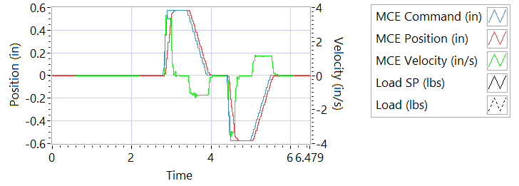

Figure - Results for Motor Three

**Step d Extension**

|  |  |  |
| --- | --- | --- |
| Description | Actual Speed / Time | Pass/Fail |
| No Load speed is 2.7 to 3.3 in/sec | 3.2254 | True |
| Time to achieve 80% of the specified stroke (+ 0.575 ins) is 170+9/-9 ms seconds | 188 | Failed |

**Step e Retraction**

|  |  |  |
| --- | --- | --- |
| Description | Actual Speed / Time | Pass/Fail |
| No Load speed is 2.7 to 3.3 in/sec | -3.2393 | Failed |
| Time to achieve 80% of the specified stroke (+ 0.575 ins) is 170+9/-9 ms seconds | 184 | Failed |

6.7.5.3.2 **MCE 3 Frequency Response Test**

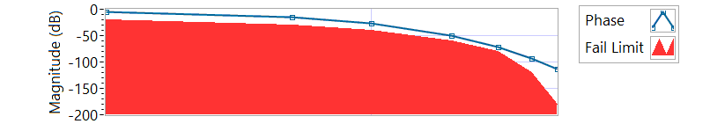

Figure - Phase for Motor Three

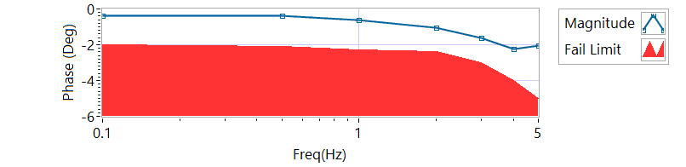

Figure - Magnitude for Motor Three

**Step d**

|  |  |  |  |  |
| --- | --- | --- | --- | --- |
| **Frequency** | **Magnitude**  **(dB)** | **Phase**  **(Deg)** | **Min phase**  **(Deg)** | **Pass/Fail** |
| 0.1 Hz | -0.36756 | -4.3128 | -20 | True |
| 0.5 Hz | -0.36756 | -14.526 | -30 | True |
| 1 Hz | -0.613471 | -26.784 | -40 | True |
| 2 Hz | -1.06518 | -49.248 | -60 | True |
| 3 Hz | -1.60713 | -71.496 | -80 | True |
| 4 Hz | -2.2495 | -93.744 | -120 | True |
| 5 Hz | -2.04491 | -113.04 | -180 | True |

6.7.6 Performance Test – Loaded Operation

6.7.6.1 **Step and Frequency Response Test - Loaded**

6.7.6.1.1 **MCE1 – Step Response Test**

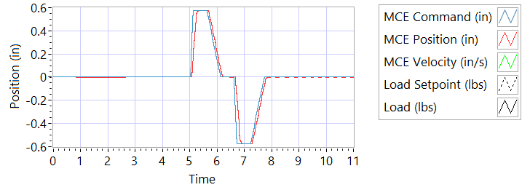

Figure - Results for Motor One Loaded

Step response Test

**Step j – 225 lbf tension**

|  |  |  |
| --- | --- | --- |
| Description | Actual Value | Pass/Fail |
| speed between 2.07 and 2.53 in/sec | 3.1602 | True |
| Time to achieve 80% of the specified stroke (+ 0.575 ins) is 170 +9/-9 ms | 167 | True |

**Step k – 225 lbf tension**

|  |  |  |
| --- | --- | --- |
| Description | Actual Value | Pass/Fail |
| speed between 2.07 and 2.53 in/sec | -3.1589 | Failed |
| Time to achieve 80% of the specified stroke (- 0.575 ins) is 170 +9/-9 ms | 184 | Failed |

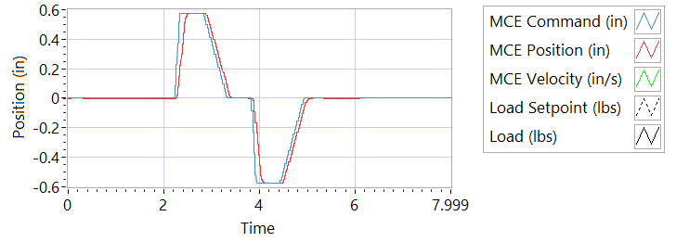

Figure - Results for Motor One Loaded

**Step n – 225 lbf compression**

|  |  |  |
| --- | --- | --- |
| Description | Actual Value | Pass/Fail |
| speed between 2.07 and 2.53 in/sec | 3.1192 | True |
| Time to achieve 80% of the specified stroke (+ 0.575 ins) is 170 +9/-9 ms | 191 | Failed |

**Step o – 225 lbf compression**

|  |  |  |
| --- | --- | --- |
| Description | Actual Value | Pass/Fail |
| speed between 2.07 and 2.53 in/sec | -3.3147 | Failed |
| Time to achieve 80% of the specified stroke (- 0.575 ins) is 170 +9/-9 ms | 187 | Failed |

6.7.6.1.2 **MCE 1 – Frequency Response Test**

**Step d – 225 lbf Tension**

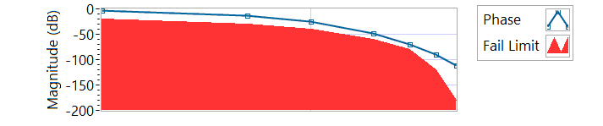

Figure - Phase for Motor One Loaded Tension

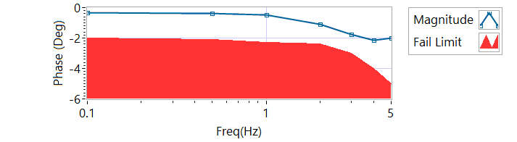

Figure - Magnitude for Motor One Loaded Tension

|  |  |  |  |  |
| --- | --- | --- | --- | --- |
| **Frequency** | **Magnitude**  **(dB)** | **Phase**  **(Deg)** | **Min phase**  **(Deg)** | **Pass/Fail** |
| 0.1 HZ | -0.339081 | -3.294 | -20 | Pass |
| 0.5 HZ | -0.367559 | -12.852 | -30 | Pass |
| 1 HZ | -0.49688 | -24.408 | -40 | Pass |
| 2 HZ | -1.09614 | -47.808 | -60 | Pass |
| 3 HZ | -1.75646 | -69.876 | -80 | Pass |
| 4 HZ | -2.13719 | -90.72 | -120 | Pass |
| 5 HZ | -1.98294 | -111.96 | -180 | Pass |

**Step h – 225 lbf Compression**

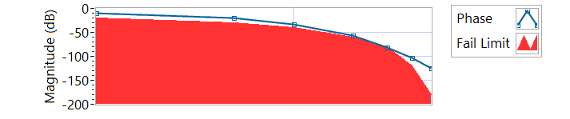

Figure - Phase for Motor One Loaded Compression

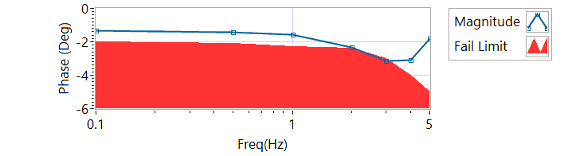

Figure - Magnitude for Motor One Loaded Compression

|  |  |  |  |  |
| --- | --- | --- | --- | --- |
| **Frequency** | **Magnitude**  **(dB)** | **Phase**  **(Deg)** | **Min Phase**  **(Deg)** | **Pass/Fail** |
| 0.1 HZ | -1.33197 | -10.7136 | -20 | Pass |
| 0.5 HZ | -1.44426 | -20.772 | -30 | Pass |
| 1 HZ | -1.59079 | -33.264 | -40 | Pass |
| 2 HZ | -2.32718 | -57.312 | -60 | Pass |
| 3 HZ | -3.1393 | -80.892 | -80 | Failed |
| 4 HZ | -3.09155 | -103.248 | -120 | Pass |
| 5 HZ | -1.83286 | -125.64 | -180 | Pass |

6.7.6.1.3 **MCE 2 – Step Response Test**

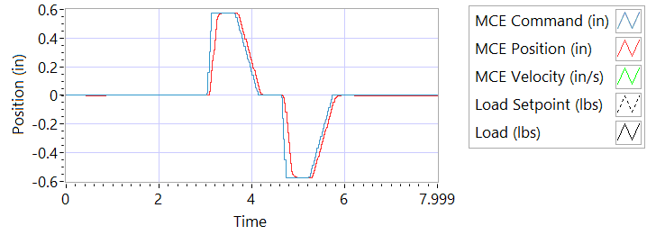

Figure - Results for Motor Two Loaded Tension

**Step j – 225 lbf tension**

|  |  |  |
| --- | --- | --- |
| Description | Actual Value | Pass/Fail |
| speed between 2.07 and 2.53 in/sec | 2.944 | True |
| Time to achieve 80% of the specified stroke (+ 0.575 ins) is 170 +9/-9 ms | 186 | Failed |

**Step k – 225 lbf tension**

|  |  |  |
| --- | --- | --- |
| Description | Actual Value | Pass/Fail |
| speed between 2.07 and 2.53 in/sec | -2.6569 | Failed |
| Time to achieve 80% of the specified stroke (- 0.575 ins) is 170 +9/-9 ms | 204 | Failed |

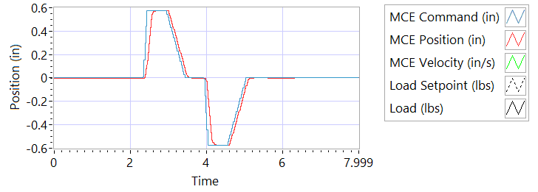

Figure - Results for Motor Two Loaded Tension

**Step n – 225 lbf compression**

|  |  |  |
| --- | --- | --- |
| Description | Actual Value | Pass/Fail |
| speed between 2.07 and 2.53 in/sec | 2.7419 | True |
| Time to achieve 80% of the specified stroke (+ 0.575 ins) is 170 +9/-9 ms | 213 | Failed |

**Step o – 225 lbf compression**

|  |  |  |
| --- | --- | --- |
| Description | Actual Value | Pass/Fail |
| speed between 2.07 and 2.53 in/sec | -2.946 | Failed |
| Time to achieve 80% of the specified stroke (- 0.575 ins) is 170 +9/-9 ms | 188 | Failed |

6.7.6.1.4 **MCE 2 – Frequency response Test**

**Step d – 225 lbf Tension**

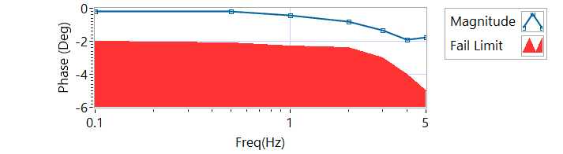

Figure - Magnitude for Motor Two Loaded Tension

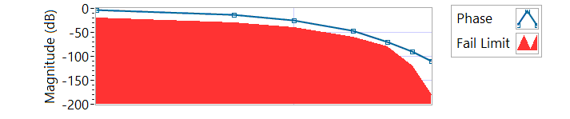

Figure - Phase for Motor Two Loaded Tension

|  |  |  |  |
| --- | --- | --- | --- |
| **Frequency** | **Phase** | **Max phase** | **Pass/Fail** |
| 0.1 HZ | -3.2004 | -20 | True |
| 0.5 HZ | -12.87 | -30 | True |
| 1 HZ | -24.228 | -40 | True |
| 2 HZ | -47.304 | -60 | True |
| 3 HZ | -70.092 | -80 | True |
| 4 HZ | -90.432 | -120 | True |
| 5 HZ | -110.16 | -180 | True |

**Step h – 225 lbf Compression**

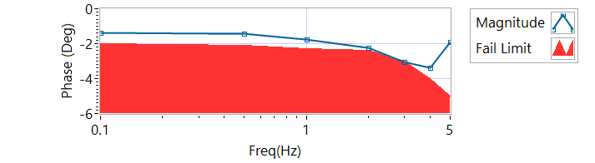

Figure - Magnitude for Motor Two Loaded Compression

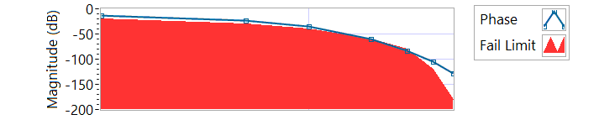

Figure - Phase for Motor Two Loaded Compression

|  |  |  |  |
| --- | --- | --- | --- |
| **Frequency** | **Phase** | **Max phase** | **Pass/Fail** |
| 0.1 HZ | -12.8376 | -20 | True |
| 0.5 HZ | -23.472 | -30 | True |
| 1 HZ | -35.784 | -40 | True |
| 2 HZ | -59.4 | -60 | True |
| 3 HZ | -82.836 | -80 | Failed |
| 4 HZ | -105.696 | -120 | True |
| 5 HZ | -127.8 | -180 | True |

6.7.6.1.5 **MCE 3 – Step Response Test**

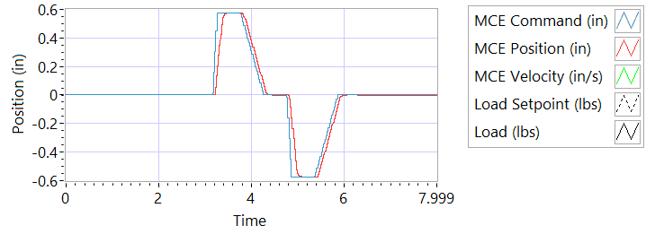

Figure - Results for Motor Three

**Step j – 225 lbf tension**

|  |  |  |
| --- | --- | --- |
| Description | Actual Value | Pass/Fail |
| speed between 2.07 and 2.53 in/sec | 3.1068 | True |
| Time to achieve 80% of the specified stroke (+ 0.575 ins) is 170 +9/-9 ms | 195 | Failed |

**Step k – 225 lbf tension**

|  |  |  |
| --- | --- | --- |
| Description | Actual Value | Pass/Fail |
| speed between 2.07 and 2.53 in/sec | -2.8732 | Failed |
| Time to achieve 80% of the specified stroke (- 0.575 ins) is 170 +9/-9 ms | 212 | Failed |

**Step n – 225 lbf compression**

|  |  |  |
| --- | --- | --- |
| Description | Actual Value | Pass/Fail |
| speed between 2.07 and 2.53 in/sec | 2.7024 | True |
| Time to achieve 80% of the specified stroke (+ 0.575 ins) is 170 +9/-9 ms | 211 | Failed |

**Step o – 225 lbf compression**

|  |  |  |
| --- | --- | --- |
| Description | Actual Value | Pass/Fail |
| speed between 2.07 and 2.53 in/sec | -2.9547 | Failed |
| Time to achieve 80% of the specified stroke (- 0.575 ins) is 170 +9/-9 ms | 207 | Failed |

6.7.6.1.6 **MCE 3 – Frequency Response Test**

**Step d – 225 lbf Tension**

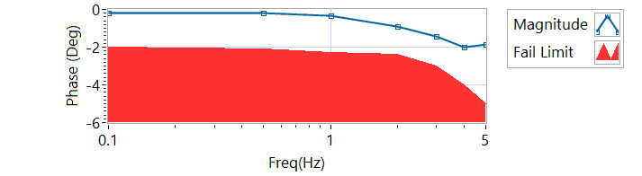

Figure - Magnitude for Motor Three Loaded Tension

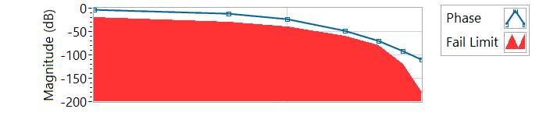

Figure - Phase for Motor Three Loaded Tension

|  |  |  |  |
| --- | --- | --- | --- |
| **Frequency** | **Phase** | **Max phase** | **Pass/Fail** |
| 0.1 HZ | -2.898 | -20 | True |
| 0.5 HZ | -12.096 | -30 | True |
| 1 HZ | -23.94 | -40 | True |
| 2 HZ | -47.592 | -60 | True |
| 3 HZ | -69.66 | -80 | True |
| 4 HZ | -90.864 | -120 | True |
| 5 HZ | -110.7 | -180 | True |

**Step h – 225 lbf Compression**

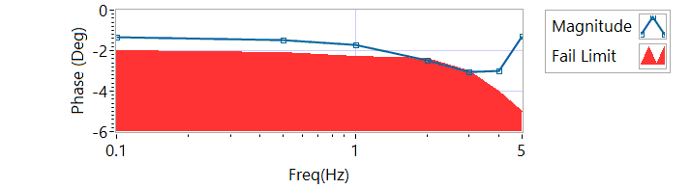

Figure - Magnitude for Motor Three Loaded Compression

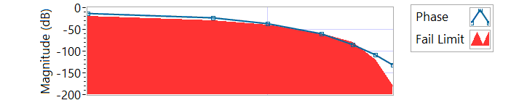

Figure - Phase for Motor Three Loaded Compression

|  |  |  |  |
| --- | --- | --- | --- |
| **Frequency** | **Phase** | **Max phase** | **Pass/Fail** |
| 0.1 HZ | -13.1976 | -20 | True |
| 0.5 HZ | -23.49 | -30 | True |
| 1 HZ | -36.288 | -40 | True |
| 2 HZ | -60.192 | -60 | Failed |
| 3 HZ | -84.672 | -80 | Failed |
| 4 HZ | -108.576 | -120 | True |
| 5 HZ | -130.86 | -180 | True |

6.7.7 Holding Load Test

6.7.7.1 Brake OFF, LEMA Output Locked

|  |  |  |  |  |
| --- | --- | --- | --- | --- |
| MCE | Expected Output force, lbf | Actual Output force, lbf | Output force, Pass/Fail | Position feedback signals (all sensors) Pass/Fail |
| MCE 1, step i – extend 0.2 in | 325-800 lbf | -274.4214 | Failed | RESULTS |
| MCE 1, step k - retract 0.2 in | 325-800 lbf | 277.843 | Failed | RESULTS |
| MCE 2, m step i – extend 0.2 in | 325-800 lbf | -280.9922 | Failed | RESULTS |
| MCE 2, m step k - retract 0.2 in | 325-800 lbf | 244.7019 | Failed | RESULTS |
| MCE 3 m step i – extend 0.2 in | 325-800 lbf | -206.0459 | Failed | RESULTS |
| MCE 3 m step k - retract 0.2 in | 325-800 lbf | 271.4707 | Failed | RESULTS |

**6.7.7.2 Brake ON, LEMA Output Free**

|  |  |  |  |  |
| --- | --- | --- | --- | --- |
| MCE | 12.6 +- TBD Amps for 3-5 sec | Current Pass/Fail | Position feedback | Position Feedback Pass/Fail |
| MCE 1, step I – extend 0.2 in | 6.0015 | True | -0.5454 | Pass |
| MCE 1, step k - retract 0.2 in | -5.9854 | True | -0.547 | Pass |
| MCE 2, step i – extend 0.2 in | 6.0088 | True | -0.554 | Failed |
| MCE 2, step k - retract 0.2 in | -5.9938 | True | -0.5556 | Failed |
| MCE 3 step i– extend 0.2 in | 5.999 | True | -0.5627 | Failed |
| MCE 3 step k - retract 0.2 in | -5.9866 | True | -0.5627 | Failed |

**6.7.7.3 Brake Release test**

**Step d –** LEMA reaches commanded position

|  |  |  |  |  |
| --- | --- | --- | --- | --- |
| Description | Expected | Tolerance | Position | Pass/Fail |
| MCE1 /Motor 1 | 0.2 |  | 0.187 | Pass |
| MCE2 /Motor 2 | 0.2 |  | 0.1876 | Pass |
| MCE3 /Motor 3 | 0.2 |  | 0.1817 | Pass |

6.7.8 Backlash

6.7.8.1 **Simplex Brake 1 – ON; Duplex brake 2 – OFF**

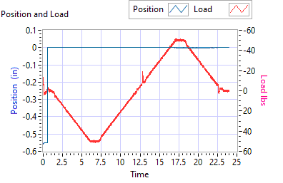

Figure - Backlash Simplex brake 1 On, Duplex brake 2 Off

|  |  |  |  |
| --- | --- | --- | --- |
| Load (lbf) | Backlash (ins) | | Pass/Fail |
| Step e +/- 35 lbf tension (motor 2 and motor 3 ZERO position) | 49.9527 | | Pass |
| Step e +/- 25 lbf compression  (motor 2 and motor 3 ZERO position) | -50.4277 | | Pass |
| Step g,Total backlash  New units: 0.0144 ins  In Service Units: 0.019 ins | -0.5572 | | Failed |
| All channels feedback signals remain within allowable limits | Allowable limit | Actual Value | Pass/Fail |
| Motor 1 Tension |  |  |  |
| Motor 1 Compression |  |  |  |
| Motor 2 Tension |  |  |  |
| Motor 2 Compression |  |  |  |
| Motor 3 Tension |  |  |  |
| Motor 3 Compression |  |  |  |
| M1 Tension |  |  |  |
| M1 Compression |  |  |  |
| M2 Tension |  |  |  |
| M2 Compression |  |  |  |
| M3 Tension |  |  |  |
| M3 Compression |  |  |  |

6.6.9.2**Simplex Brake 1 – OFF; Duplex Brake 2 – ON**

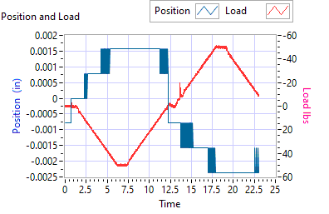

Figure - Backlash Simplex brake 1 Off, Duplex brake 2 On

|  |  |  |  |
| --- | --- | --- | --- |
| Load (lbf) | Backlash (ins) | | Pass/Fail |
| Step e +/- 35 lbf tension  (motor 1 ZERO position) | 49.9978 | | Pass |
| Step e +/- 25 lbf compression  (motor 1 ZERO position) | -50.1943 | | Pass |
| Step g, Total backlash  New units: 0.0144 ins  In Service Units: 0.019 ins | -0.0008 | | Pass |
| All channels feedback signals remain within allowable limits | Allowable limit | Actual Value | Pass/Fail |
| Motor 1 Tension |  |  |  |
| Motor 1 Compression |  |  |  |
| Motor 2 Tension |  |  |  |
| Motor 2 Compression |  |  |  |
| Motor 3 Tension |  |  |  |
| Motor 3 Compression |  |  |  |
| M1 Tension |  |  |  |
| M1 Compression |  |  |  |
| M2 Tension |  |  |  |
| M2 Compression |  |  |  |
| M3 Tension |  |  |  |
| M3 Compression |  |  |  |

6.6.9.3 **Both Brakes OFF**

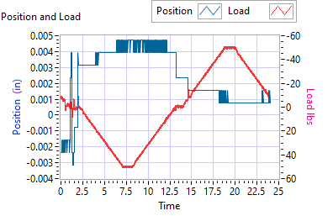

Figure - Backlash Simplex brake 1 Off, Duplex brake 2 Off

|  |  |  |  |
| --- | --- | --- | --- |
| Load (lbf) | Backlash (ins) | | Pass/Fail |
| Step e +/- 35 lbf tension  (motor 1 and motor 2 holding ZERO position) | 50.1067 | | Pass |
| Step e +/- 25 lbf compression  (motor 1 and motor 2 holding ZERO position) | -49.8413 | | Pass |
| Step g,Total backlash  New units: 0.0144 ins  In Service Units: 0.019 ins | 0.0016 | | Pass |
| All channels feedback signals remain within allowable limits | Allowable limit | Actual Value | Pass/Fail |
| Motor 1 Tension |  |  |  |
| Motor 1 Compression |  |  |  |
| Motor 2 Tension |  |  |  |
| Motor 2 Compression |  |  |  |
| Motor 3 Tension |  |  |  |
| Motor 3 Compression |  |  |  |
| M1 Tension |  |  |  |
| M1 Compression |  |  |  |
| M2 Tension |  |  |  |
| M2 Compression |  |  |  |
| M3 Tension |  |  |  |
| M3 Compression |  |  |  |